  - PROJECT DESIGN PHASE

Problem – Solution Fit
Date | 29 September 2026
Team ID | 6ab1d50c92b876d9664094bc
Project Name | Auto Ticket Classification Using Flow Designer
Maximum Marks | 2 Marks
Problem – Solution Fit Template
The project addresses delays and inconsistent routing caused by manually classifying incoming IT support tickets. ServiceNow Flow Designer can automate category, priority and assignment decisions using predefined conditions, while sending exceptions for human review.
Target customer and current behavior
Employees submit incident tickets through the ServiceNow portal. Service desk agents currently read descriptions, select categories and priorities, and route tickets to support groups. Ambiguous requests may require manual review or reassignment.
Problem–Solution Fit Canvas
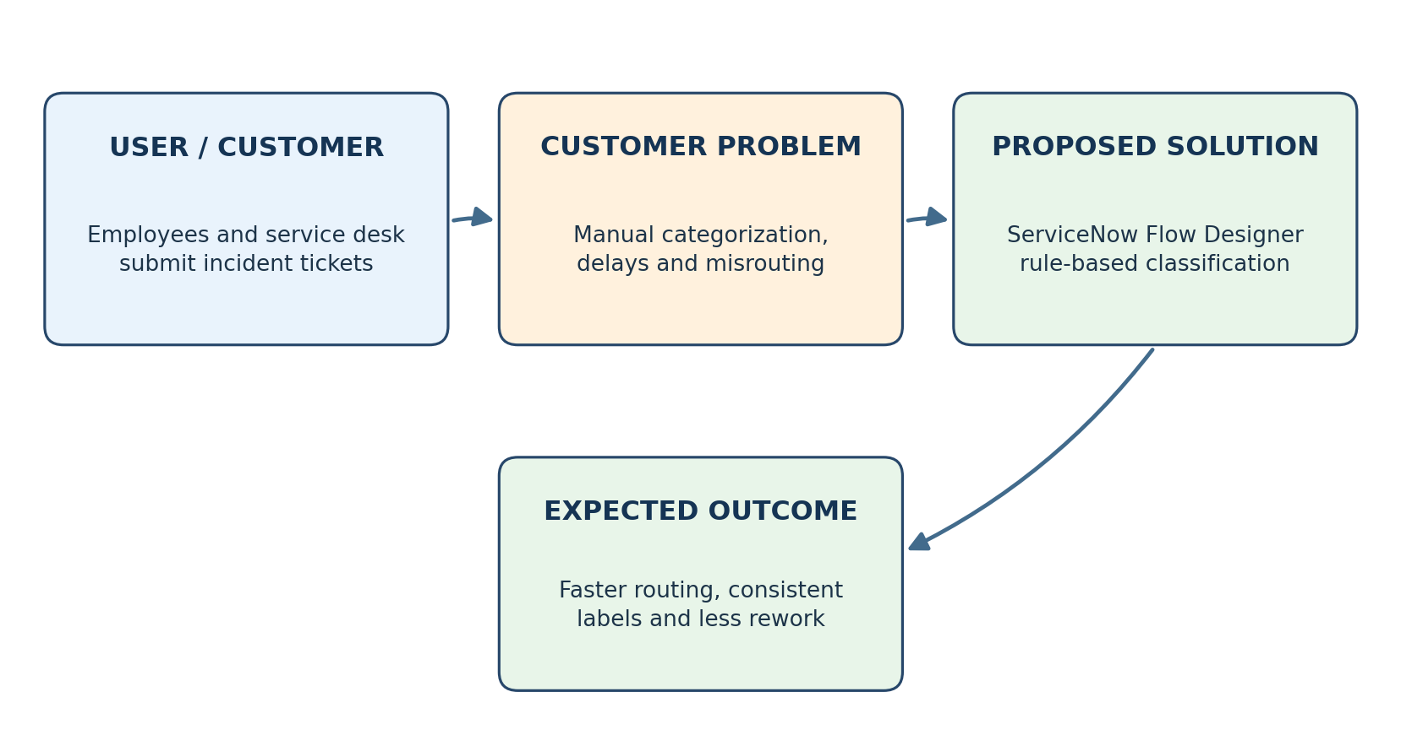

Customer problem → solution alignment
Customer pain point | Proposed solution | Expected benefit
Tickets are classified manually | Flow triggers when an incident is created | Less repetitive agent work
Tickets reach the wrong group | Conditions map keywords/category to assignment groups | Fewer avoidable reassignments
Urgent incidents wait in the queue | Priority rules evaluate impact and urgency | More consistent escalation
Unclear descriptions cause mistakes | Fallback route to service desk for review | Human oversight for uncertain cases
Proposed validation
Pilot the flow with representative test tickets. Compare manual and automated classification, measure routing accuracy and time to assignment, and collect service desk feedback. Refine the conditions when errors or unmatched cases are found.
Note: This is a proposed rule-based solution; measured improvements depend on implementation and pilot results.

